**Guide on the application setup: -**

1. The following must be present on your device: -

* Download Python: - <https://www.python.org/downloads/>
  + You can check if you have python by typing “python --version” or “py --version” in your command prompt which can be found in your search bar.

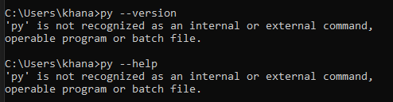

* + Successful installation will display the following

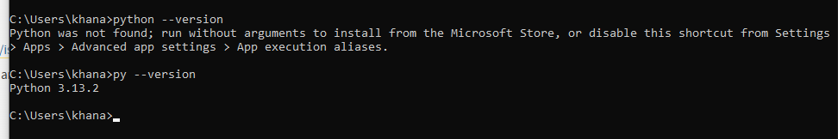

* Download Ollama: - <https://ollama.com/download/windows>

1. After the installation of Ollama, open Command Prompt through the Windows Search Bar



1. Type in “ollama run llama2” and then press “Enter” on the keyboard

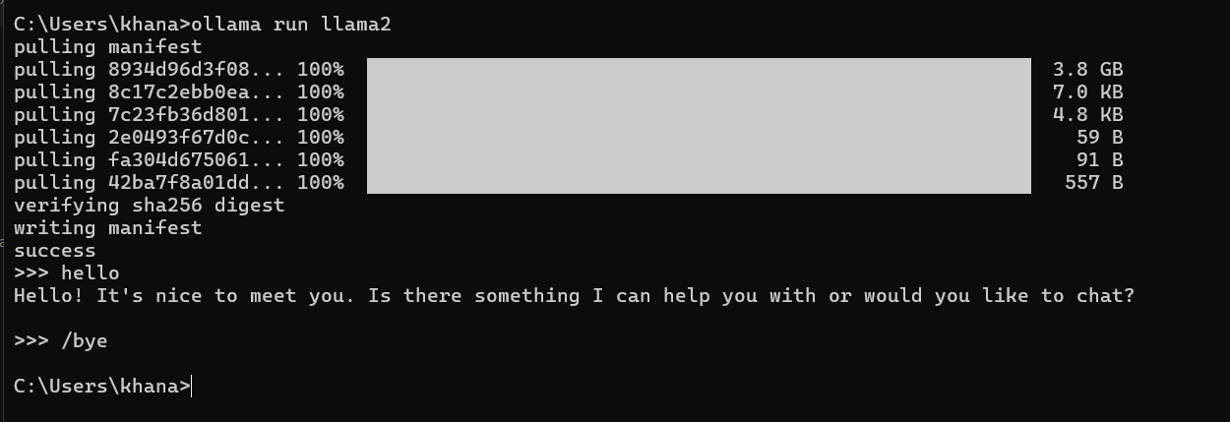

1. After facing success like in the picture above, type “/bye” and press “Enter” on the keyboard. After that close the command prompt
2. Download the given ZIP file and extract it

1. Open “Ai flask” folder

1. Open Command Prompt and copy the file path and paste it after typing “cd ” in the command prompt

1. Write the following step by step in the command prompt

* Write “py -m venv venv” and press “Enter” on the keyboard
  + If you encounter an error, then use “python” instead of “py” for the following steps



* Write “.\venv\Scripts\activate” and press “Enter” on the keyboard
* Write “py -m pip install -r requirement.txt” and press “Enter” on the keyboard

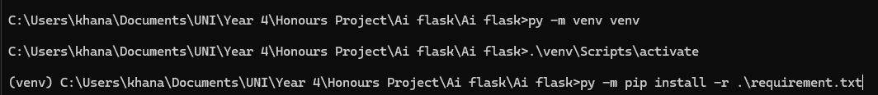

* Write “py app.py” and press “Enter” on the keyboard

1. Hold “Ctrl” button on the keyboard and Click on the link that shows after the text “Running on” and it should follow up with a link like this http://127.0.0.1:5000.
   1. Incase that doesnt work, copy and paste the link the web browser
2. After finishing with the program close the web browser and the Command Prompt and the next time you run the program, do the following: -
   1. Open the file path like you did in Step 7
   2. Write “.\venv\Scripts\activate” and press “Enter” on the keyboard
   3. Write “py app.py” and press “Enter” on the keyboard

